**Full Stack Development with MERN**

**Database Design and Development Report**

|  |  |
| --- | --- |
| Date | 18-07-24 |
| Team ID | SWTID1720076124 |
| Project Name | Online Complaint Registration and Management System |
| Maximum Marks |  |

**Project Title**: **Online Complaint Registration and Management System**

**Date**: 18-07-2024

**Prepared by**: Divyanshi Mittal

**Objective**

The objective of this report is to outline the database design and implementation details for the Online Complaint Registration and Management project, including schema design and database management system (DBMS) integration.

**Technologies Used**

* **Database Management System (DBMS):** MongoDB
* **Object-Document Mapper (ODM):** Mongoose

**Design the Database Schema**

The database schema is designed to accommodate the following entities and relationships:

**1. User**

- Attributes: [list attributes like _id, name, email, username, password, role, phone number]

**2. Complaints**

- Attributes: [list attributes like ticketid, name, phoneNum, email, title, description, status, userid, agentId]

**Implement the Database using MongoDB**

The MongoDB database is implemented with the following collections and structures:

Database Name: projectdbs]

1. Collection: users

- Schema:

```

{

_id:{type:String, required:true},

    name: { type: String, required: true },

    email: { type: String, required: true },

    address: { type: String, required: true },

    mobileNumber: { type: Number, required: true },

    role:{type: String, required:true},

    username: { type: String, required: true },

    password: { type: String, required: true },

}

```

2. Collection: userComplaints

- Schema:

```

{

ticketId:{type:String,required:true},

    name:{type:String, required:true},

    phoneNum:{type:Number,required:true},

    email:{type:String,required:true},

    complaintTitle:{type:String,required:true},

    complaintDescription:{type:String,required:true},

    status:{type:String,required:true},

    userId:{type:String,required:true},

    agentId:{type:String,required:false}

}

```

**Integration with Backend**

* Database connection: Give Screenshot of Database connection done using Mongoose

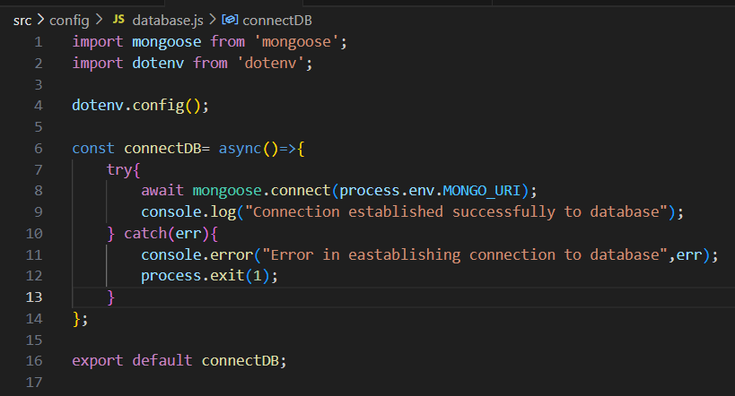

* The backend APIs interact with MongoDB using Mongoose ODM Key interactions include:
  + User Management:

1. When the user submits a complaint, it creates a new entry in complaints collection, with the default status “pending”
2. When the user signs up their credentials are inserted in the user collection
   * Agent Management:
3. When the agent clicks the resolve button the status of that particular ticket gets changed from “processing” to “resolved”
   * Admin Management:
4. When the admin assigns the agent to the complaint, the status changes from “pending” to “processing”, also, it updates the agent field in the document of the ticket in the complaints collection with the agent ID.